Best ARIMA order from CV: (1, 1, 0) CV MAPE: 15.86367441077431
Best GRU cfg: {'units': 96, 'dropout': 0.15, 'window': 21} val_loss: 0.037046317011117935

=== HOLDOUT (28d) METRICS ===
MAE: 477.12
RMSE: 635.80
MAPE: 13.97%
Accuracy (1-MAPE): 86.03%
ARIMA-only MAPE: 14.98% → ΔMAPE vs Hybrid: +1.02 pts
alpha=0.000, beta=0.091
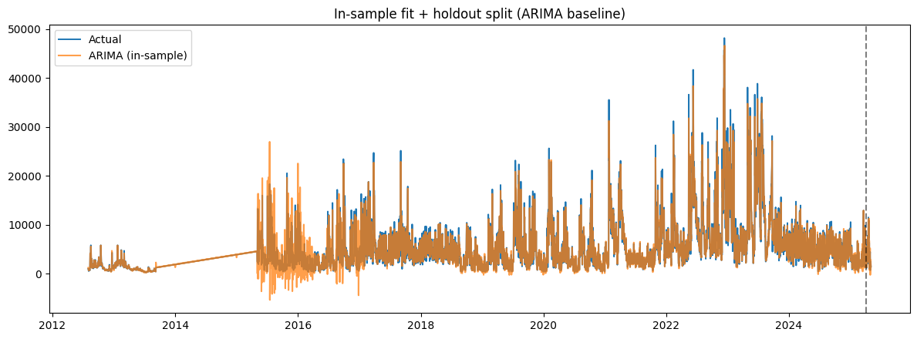
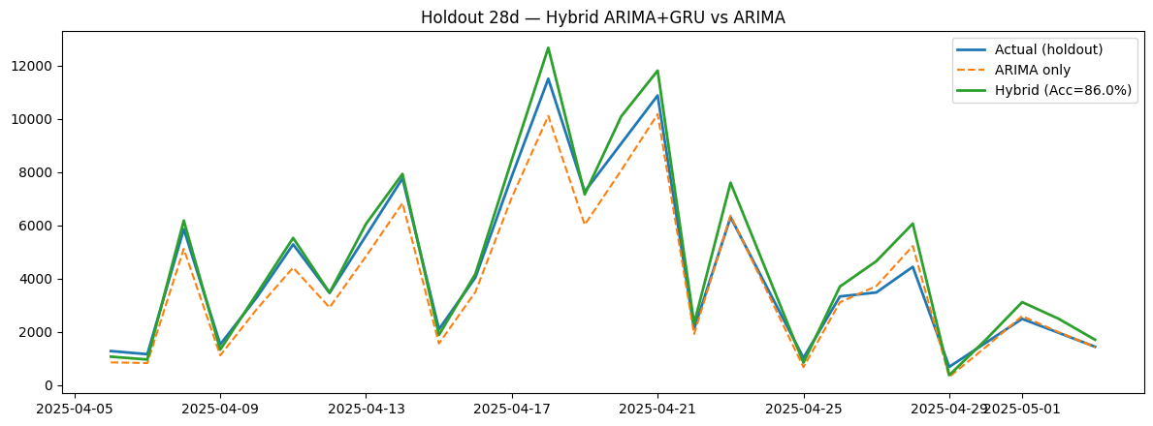
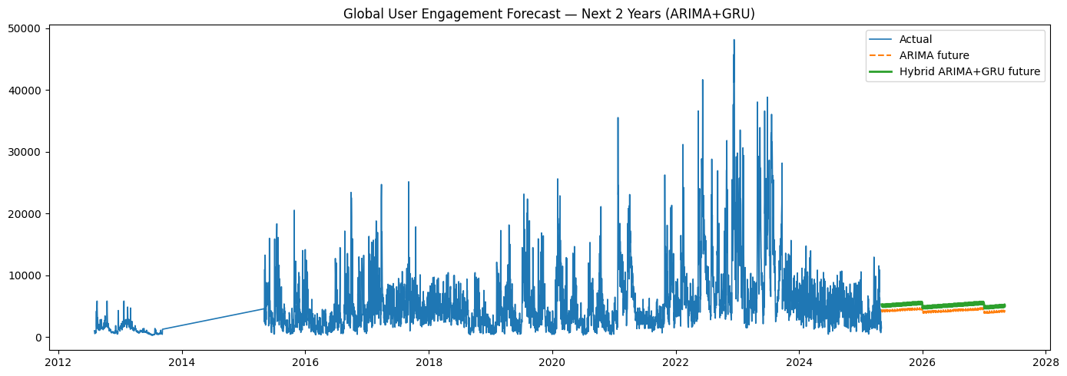
WARNING:absl:You are saving your model as an HDF5 file via `model.save()` or `keras.saving.save_model(model)`. This file format is considered legacy. We recommend using instead the native Keras format, e.g. `model.save('my_model.keras')` or `keras.saving.save_model(model, 'my_model.keras')`.

Artifacts: /content/hybrid_arima_gru_artifacts
- 2year_forecast_arima_gru.csv
- arima_model.pkl
- arima_order.json
- gru_residual.h5
- metrics_arima_gru.json
- x_scaler.npy
- y_scaler.npy

Checkpoints: /content/arima_gru_ckpts
- gru_best_win21.keras
- gru_best_win28.keras

